**Report Overview**

This document provides a comprehensive overview of the Power BI report created for **BayWa r.e. Solar Trade** subsidiaries. The report is designed to offer both operational managers and C-level executives insightful analyses to make informed decisions.

To view the report, open file ‘BayWare.pbix’ with Power BI Desktop on your computer.

***Number of Pages/Dashboards: 4***

* For Operations managers
  1. Inventory Overview (Page 1)
  2. Purchase Order Analysis (Page 2)
  3. Sales Order Analysis (Page 3)
* For C-Level

1. C-Level Executive Dashboard (Page 4)

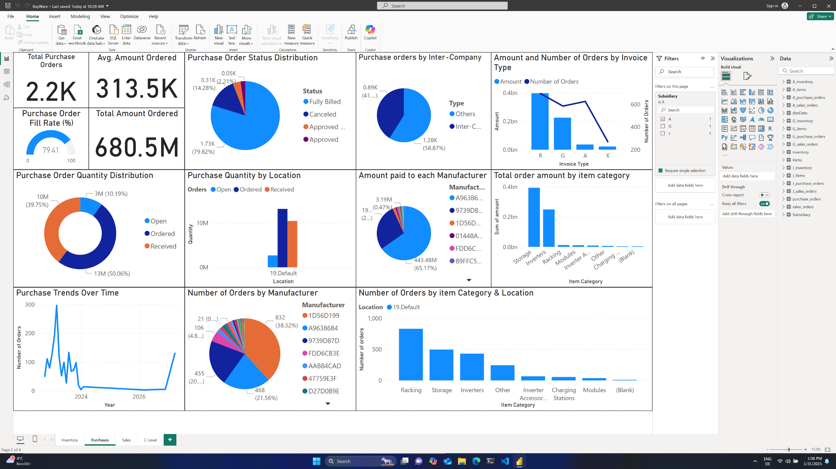

***Page-Level Filters for page 1, 2 & 3 (right side of report):***

* Subsidiary Filter: Allows users to select between subsidiaries A, G, and J. One subsidiary can be selected at a time.

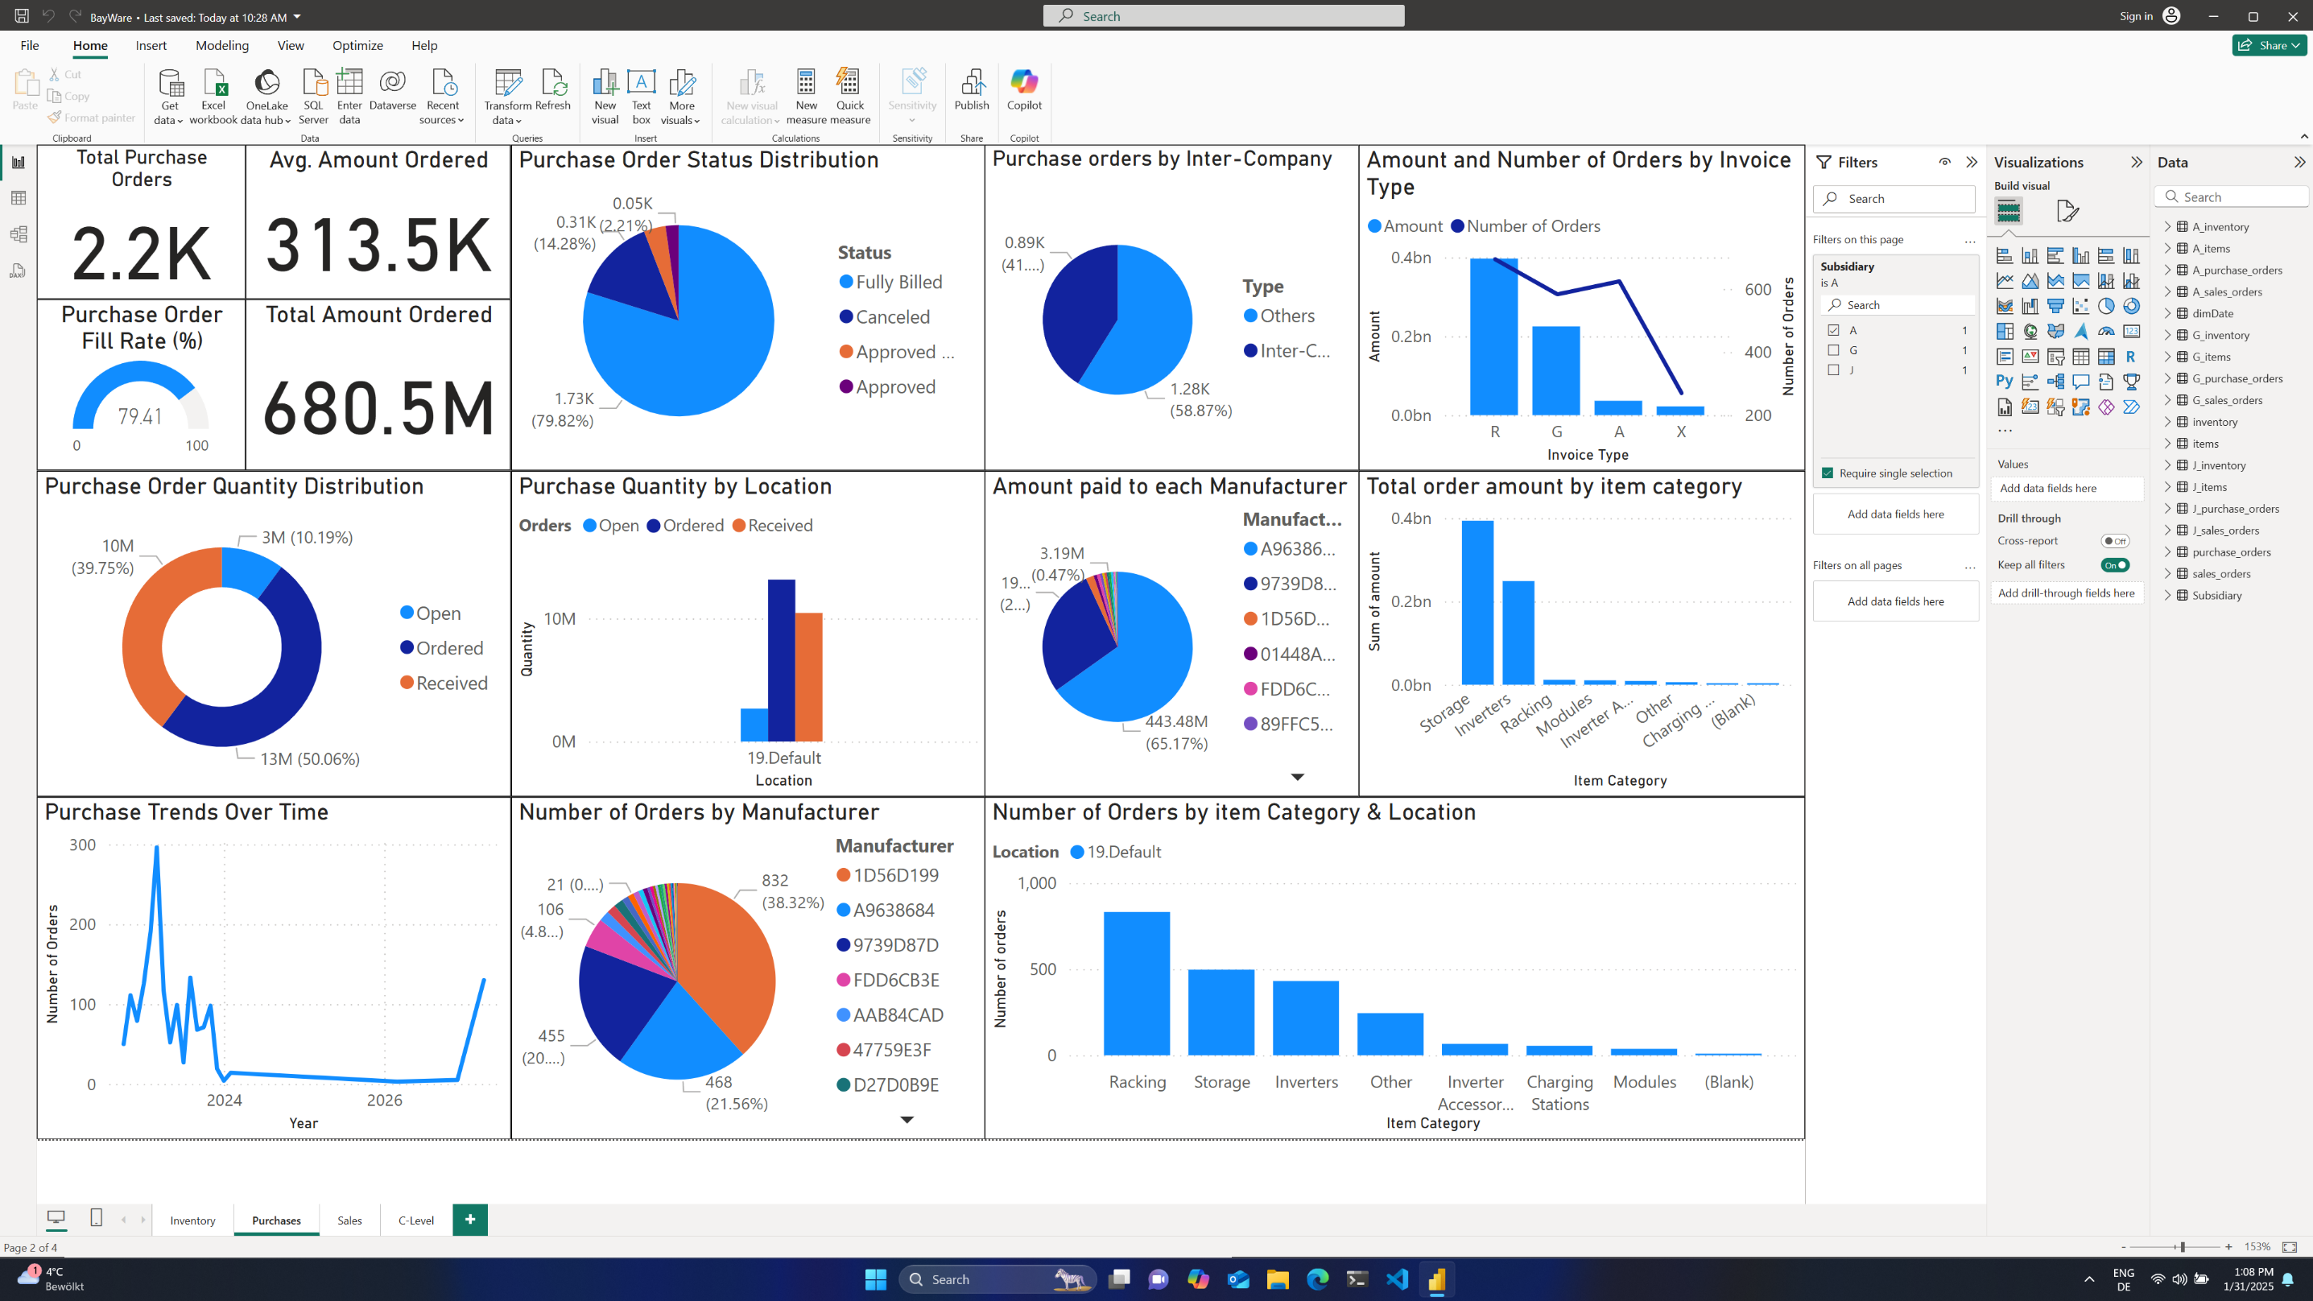

**Dataset Relationship Schema**

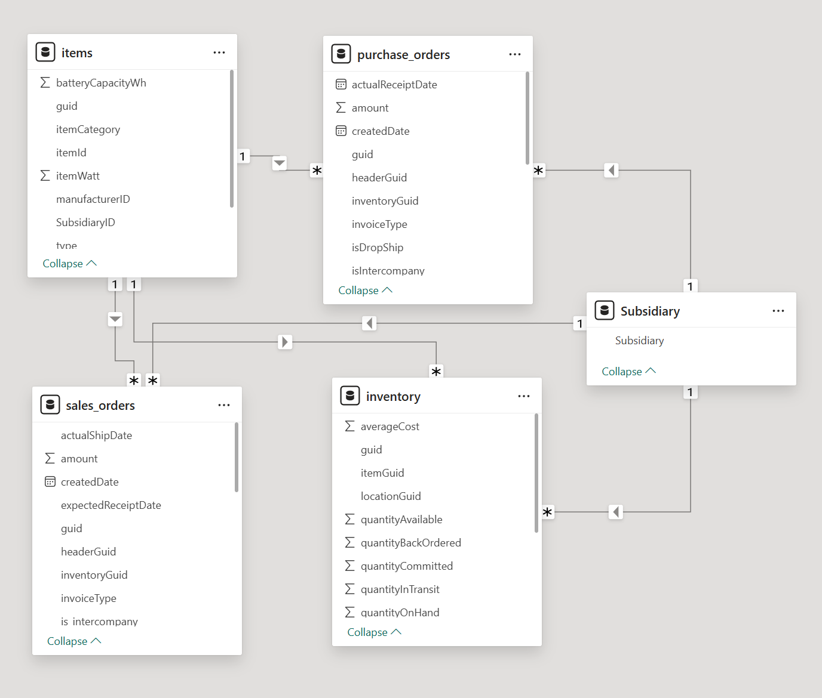

**Subsidiary A** (Screenshots)

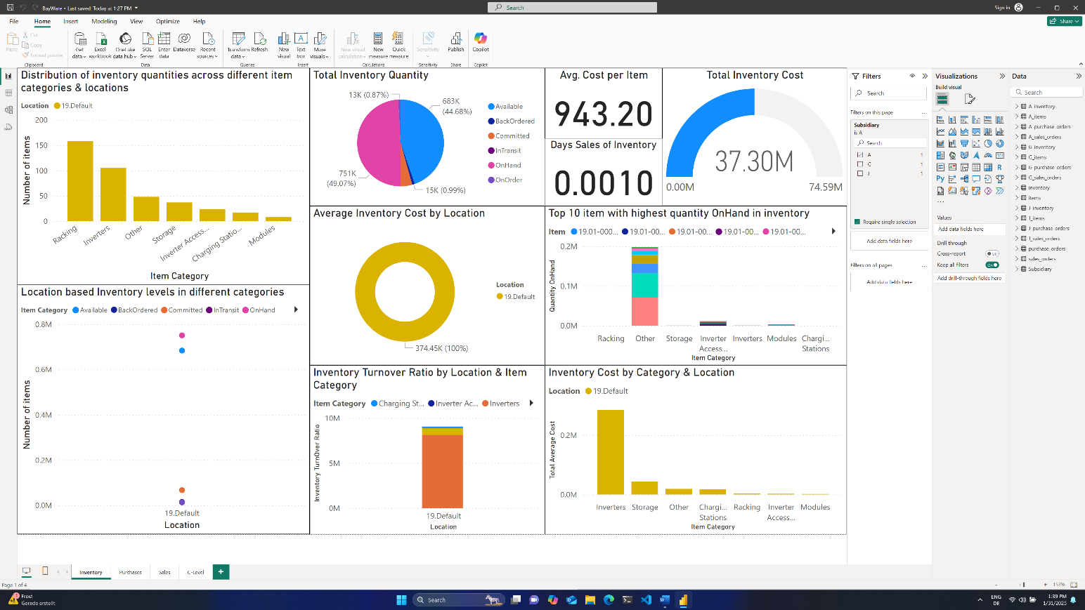

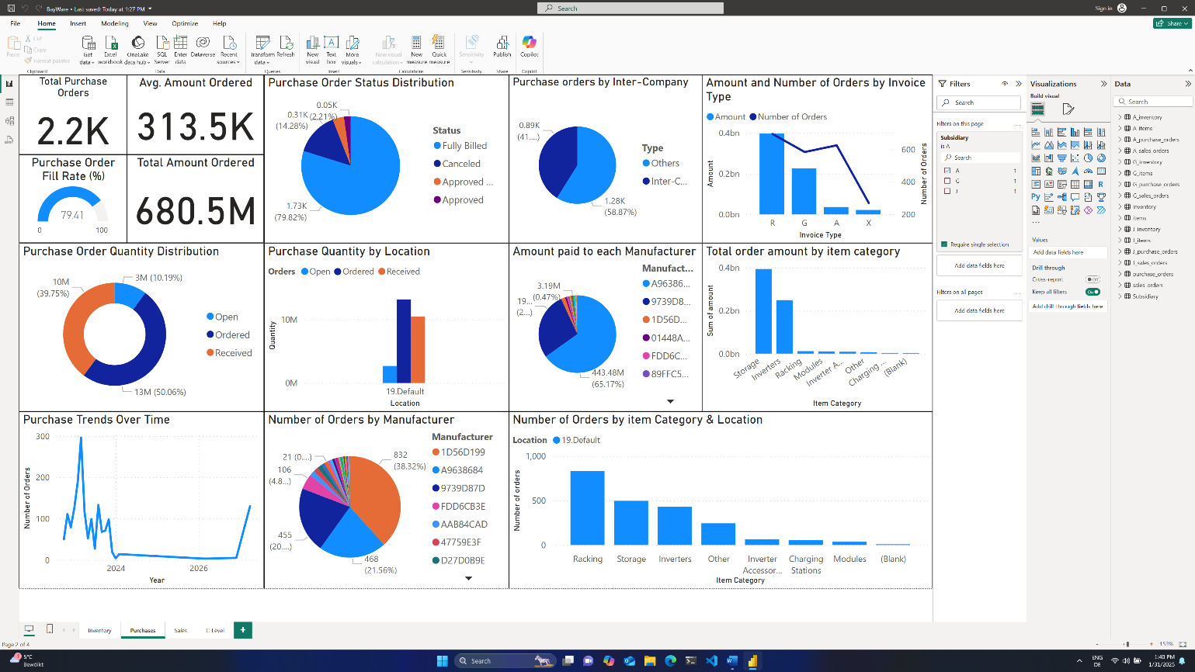

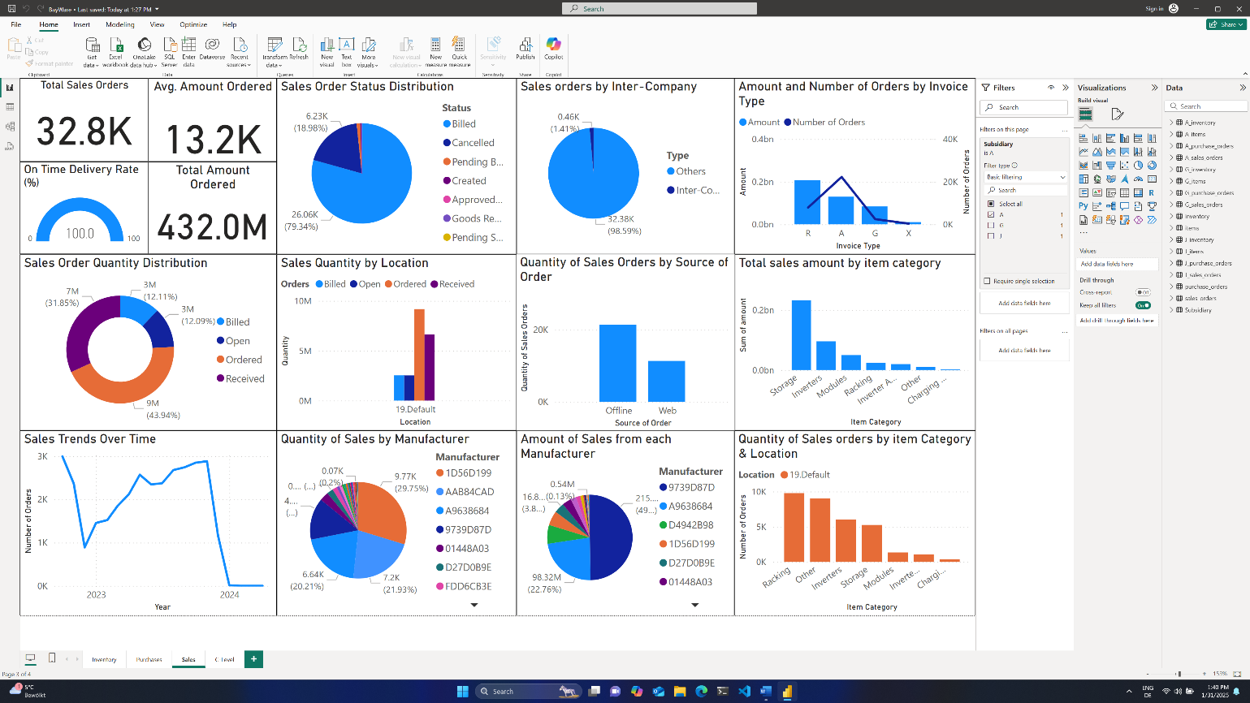

**Subsidiary G** (Screenshots)

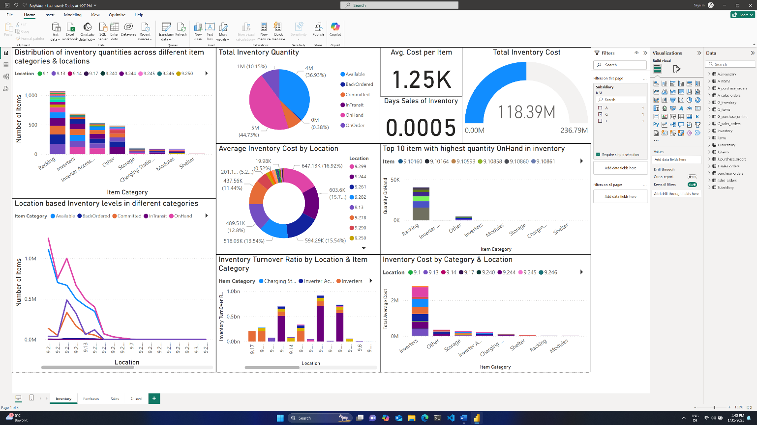

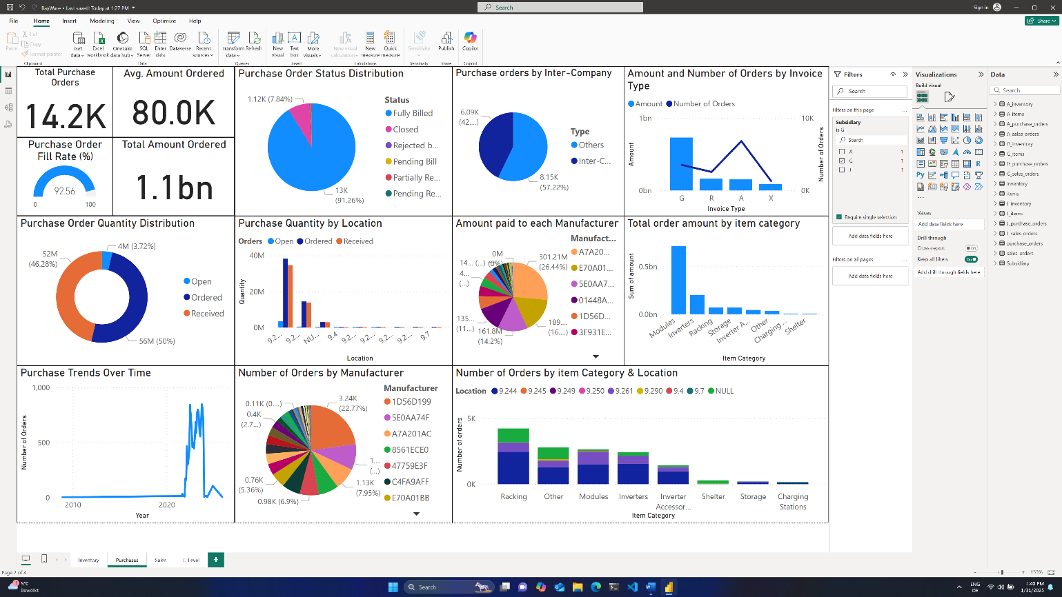

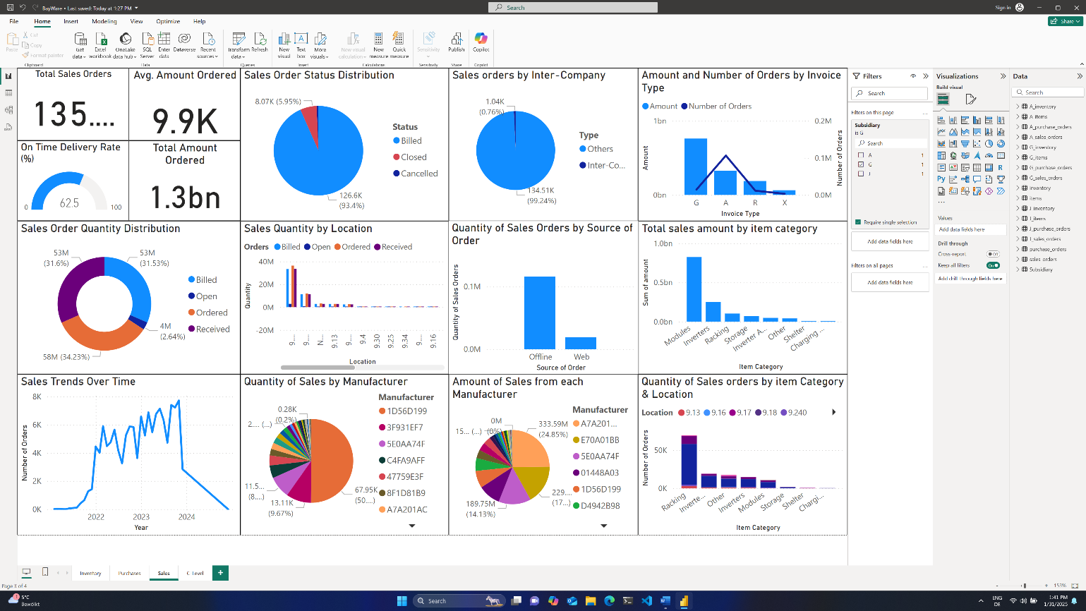

**Subsidiary J** (Screenshots)

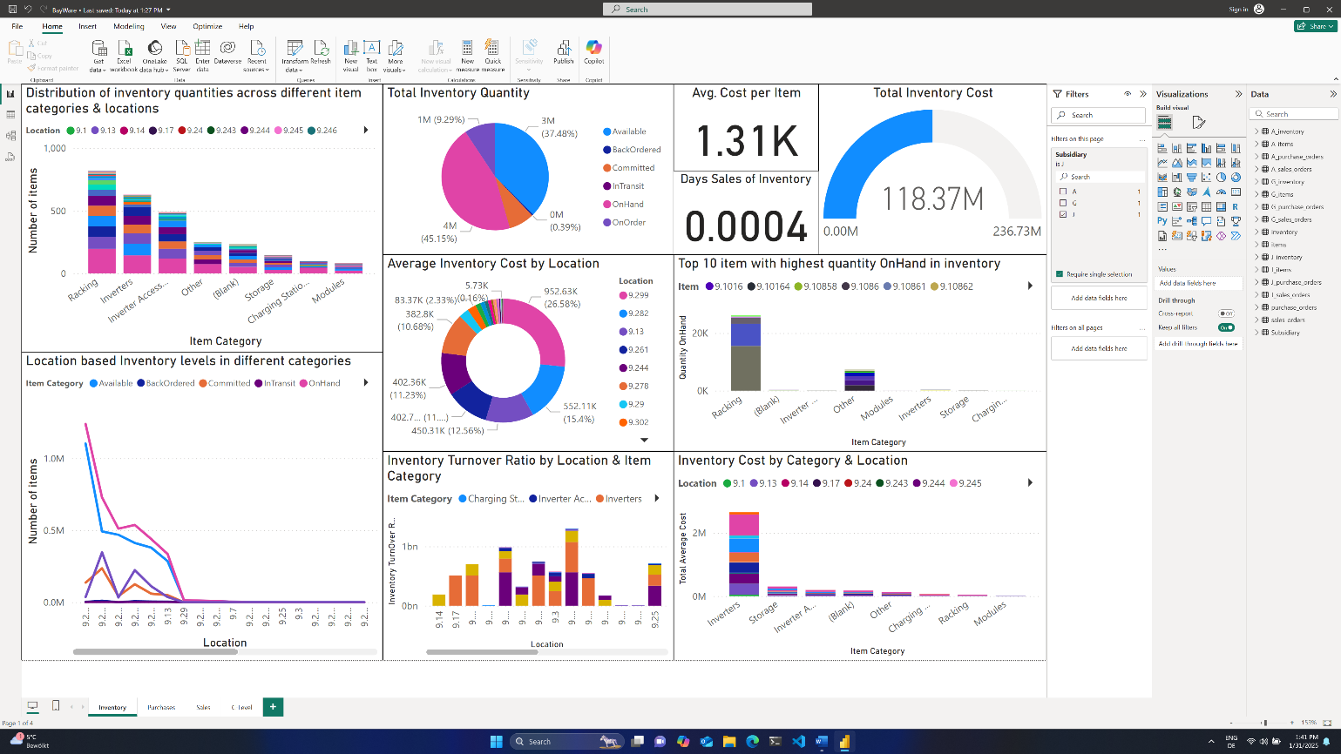

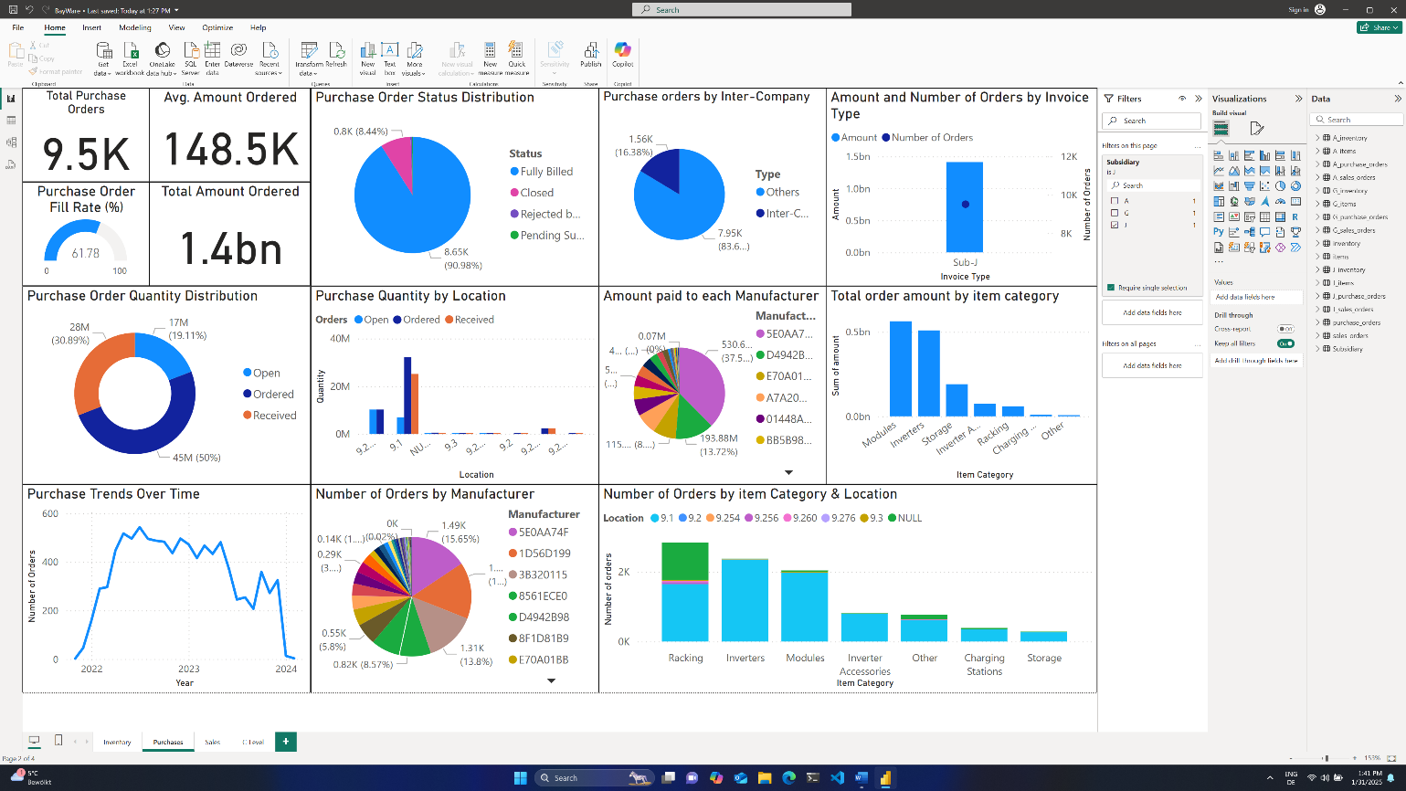

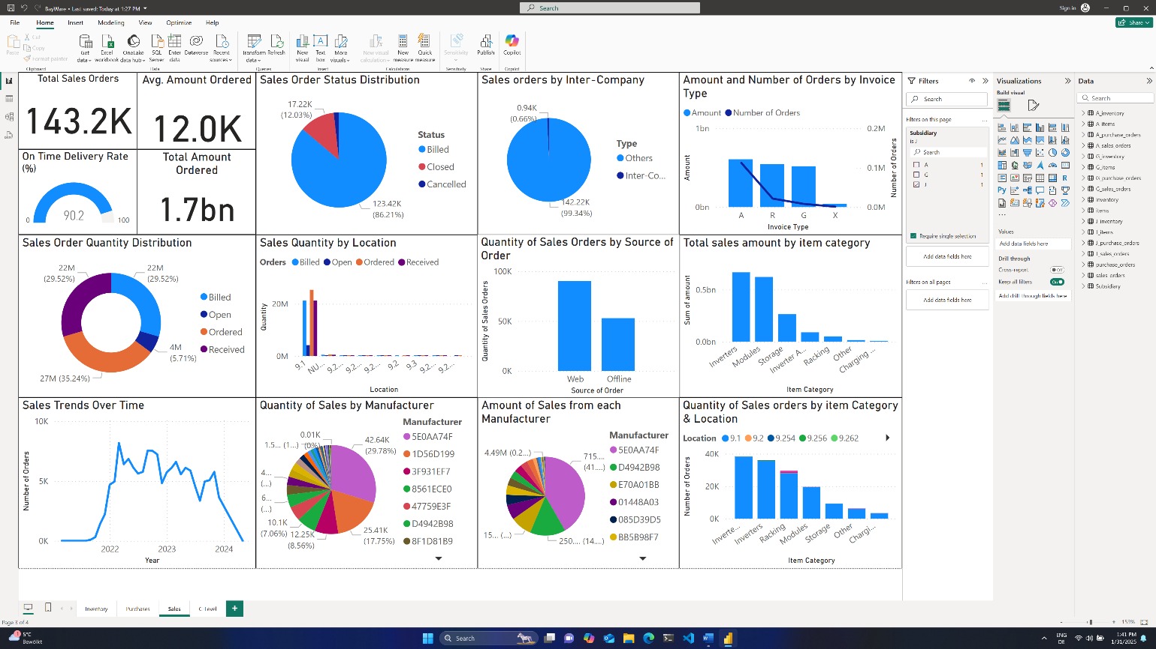

**C-Level Dashboard** (Screenshots)

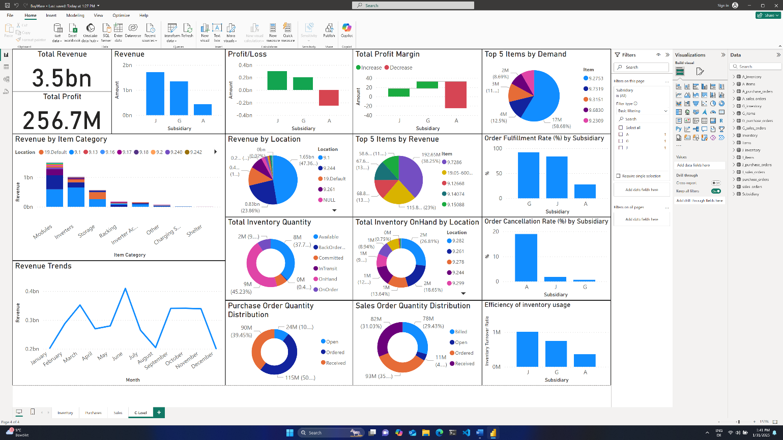

**Definitions**

Here are the definitions of some key formulas (DAX measures) used in the report KPIs in a natural language format:

**1. Total Revenue**

**Definition**: This measure calculates the total revenue generated from sales orders by summing up the amount column from the sales orders table.

**2. Total Purchase Orders**

**Definition**: This measure counts the total number of purchase orders by counting the rows in the purchase orders table.

**3. Average Order Amount**

**Definition**: This measure calculates the average amount of purchase orders by taking the average of the amount column from the purchase orders table.

**4. Average Lead Time**

**Definition**: This measure calculates the average lead time for purchase orders by taking the average difference between the actual receipt date and the transaction date.

**5. Gross Profit**

**Definition**: This measure calculates the gross profit by subtracting the total purchase cost from the total revenue. The total purchase cost is calculated by summing up the amount column from the purchase orders table.

**6. Gross Profit Margin**

**Definition**: This measure calculates the gross profit margin as a percentage by dividing the gross profit by the total revenue and multiplying by 100.

**7. Order Fulfillment Rate**

**Definition**: This measure calculates the order fulfillment rate as a percentage by dividing the total quantity billed by the total quantity ordered and multiplying by 100.

**8. Order Cancellation Rate**

**Definition**: This measure calculates the order cancellation rate as a percentage by dividing the number of canceled orders by the total number of orders and multiplying by 100.

**9. Revenue by Product Category**

**Definition**: This measure calculates the total revenue for each product category by summing the amount column from the sales orders table and grouping by the item category column from the items table.

**10. Revenue by Region**

**Definition**: This measure calculates the total revenue for each region by summing the amount column from the sales orders table and grouping by the location column from the inventory table.

**11. Monthly Revenue Trends**

**Definition**: This measure calculates the total monthly revenue by summing the amount column from the sales orders table and grouping by the MonthYear column from the Date Table.

These definitions provide a clear understanding of how the key performance indicators (KPIs) are calculated, offering valuable insights into the data analysis performed in the report.